



Write a program with print function to print single and Multiline text
LAB MANUAL

Disclaimer: The content is curated from online/offline resources and used for educational purpose only
Write a program with print function to print single and Multiline text
Objective:
To create a Python program that demonstrates how to print both single-line and multi-line text using print function. The goal is to help users understand how to format printed output effectively using Python.
Problem Statement:
Then problem is, when developing applications in Python, it is often necessary to output text in various formats. Understanding how to print both single-line and multi-line text is crucial for displaying information correctly.
Procedure:
Task 1: Single-Line Print.

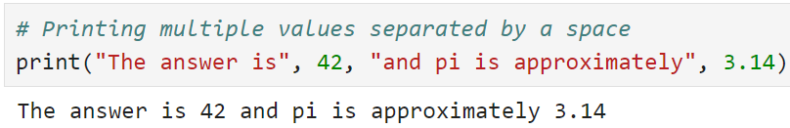 pr

Concatenating strings using the '+' operator
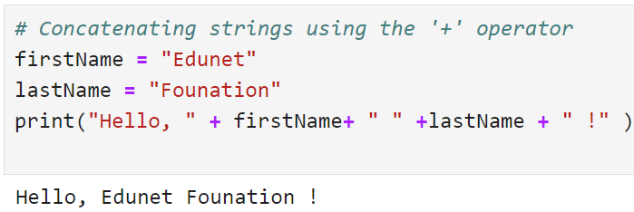
Using f-strings for formatting output
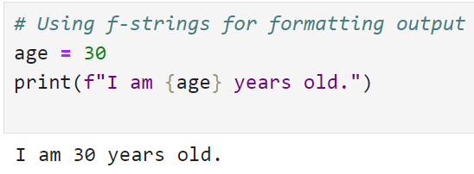

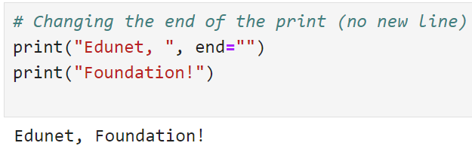crrs

Task 2:
Basic Multi-Line Print Using Triple Quotes
